DEALS TO VAIL

The small but sophisticated town of Vail is set within White River National Forest. With winter sports like skiing and snowboarding, and summer activities like golfing and hiking, there’s always something interesting and fun to do, making Vail a popular year-round destination. Book a trip to Vail via Denver International Airport on Virgin America. Live it up at 35,000 feet with WiFi, on-demand entertainment, and more on every flight.

(MARKET IMAGE HERE)

Find Deals From These Cities

INSERT FARE GRID FROM / TO Version (if available!)



Top Things To Do in Vail

Below are some of the top Vail attractions to keep in mind for when you visit.

* Tackle the slopes. With over 5,200 acres of developed ski and snowboard terrain, Vail Mountain Resort is coveted as one of the largest ski resorts in the world. The trails cater to a wide variety of skiers, from novice to expert. Awesome skiing, coupled with excellent restaurants and accommodations, makes this a much-loved destination for many visitors year after year.
* Relax and enjoy the beautiful scenery at the Betty Ford Alpine Gardens. When visiting this beautiful botanical garden, you’ll enjoy spectacular views of the Rocky Mountains, gorgeous botanicals, and serene water features.
* Take a tour of Vail Village. You’ll learn about the ski area’s history, the pioneers that created this world-class destination, and more.

Travel Tips and Resources

[Must-Dos in Vail](http://www.thedeliciousday.com/denver-and-colorado/things-to-do-in-vail)

[Vail Hotels](http://www.tripadvisor.com/Hotels-g33676-Vail_Colorado-Hotels.html)

[Vail Restaurantshttp://www.tripadvisor.com/Restaurants-g33676-Vail_Colorado.html](http://www.tripadvisor.com/Restaurants-g33676-Vail_Colorado.html)

[Vail Shopping Guide](http://www.vail.com/activities/shopping-explorer.aspx?page=viewall)

[Vail Nightlife and Entertainment](http://www.vail.com/activities/nightlife.aspx?page=viewall)

[Vail Travel Tips](http://travel.usnews.com/Vail_CO/Travel_Tips)

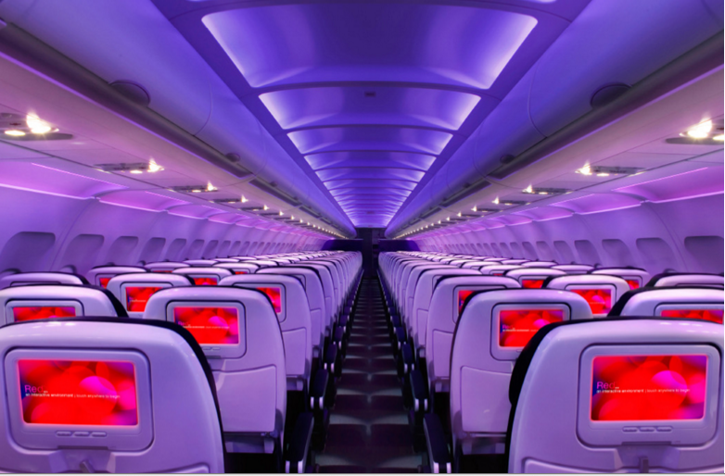

Main Cabin Main Cabin Select First Class

(add links to Cabin Class Pages)

Ready. Set. Fly.

Book your Mood-lit Ride to Vail.

Looking for flights to Vail for a relaxing getaway? Book your flight to Denver International Airport with Virgin America and then rent a car for the gorgeous drive to Vail. Stop in Idaho Springs or Silverthorne for a bite to eat along the way. When you fly with us, you’ll enjoy our unbelievably comfortable seats, mood-lit cabins, and many other thoughtful amenities that will enable you to have a relaxing flight experience.

Take a Virtual Tour

Add Terms & Conditions